Lab 3
Reza Shisheie
2708062

October 29, 2018

Part 1: Data processing methods

Based on lab 1 I pick the following attributes for test:

- Marital status:
- Gender:
- Yearly income:
- Total Children:
- Number of children at home:
- English education:
- House owner flag:
- number of cars owned:
- Region:
- Age:
For the rest of the program I am using the same code used for Lab1. Here are the preprocessing techniques:

Normalization :
In this section the non-nominal target data is normalized using min max method. Here is a list of attributes which were normalized:

- YearlyIncome
- TotalChildren
- NumberChildrenAtHome
- NumberCarsOwned
- Age

a function in python named “normalize” is defined for this purpose. Here is a sample data before and after normalization:

As you see only numeric items like salary and number of children are normalized. For instance the value 9000 in the second column which is salary is normalized to 0.5.

Standardization:
The normalized data is standardized using z-score method. A function called “z-score” is defined for this purpose. The following set is selected for standardization followed by the number of bins assigned to each one:

- YearlyIncome 10
- TotalChildren 6
- NumberChildrenAtHome 6
- NumberCarsOwned 5
- Age 15

Number of bins for each attribute is selected experimentally and were increased based on the type of data and consistency of result after changing bins. For instance the maximum value for the number of children was 5 and min 0 so I found 6 bins as the best option.

Here is data before and after standardization:

Binarization
in this section all the nominal values were binerized. Here is the list of nominal values which were binerized:

- Marital status
- Gender
- English education
- House owner flag
- Region:

Here s data at 0 and 300 before and after binerization:

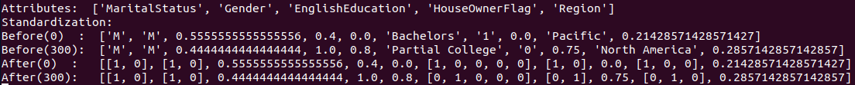
Arranging in an array
once all data is gathered, it is arranged in an array. All 0s and 1s and all other data is put into one single array. Here is one data sample before and after arranging:

Test sets:
I make two set of tests:
- The first set has all the methods mentioned above
- The second one only has binerization and does not have standardization and normalization
Part 2: Classifier selection:
Two different classifiers are selected:
- k nearest neighbor (kNN)
- Support Vector Machine (SVM)
Test data is divided into two groups. The first 2/3 is for training and the 1/3 rest is for testing.

1. kNN Method
The range of neighbors for kNN ranges from 1 to 20 and based on the best accuracy, the optimum number of neighbors is selected.The NearestNeighbors library of scikit is used.

For each test set neighbors (2~20) are found by the algorithm and the weight is the inverse of distance from neighbors to the test set. Then the goal is calculated by averaging the class f neighbors with weights:
distance = sum(weight*testClass)/sum(weights)
weight = 1/testDistance

2. SVM Method

For SVM has several different kernels and methods were tested which is listed below:
- 4 kernel types including: linear, polynomial, sigmod, and rbf
- 3 implementation: SVC, NuSVC, SVR
SVC

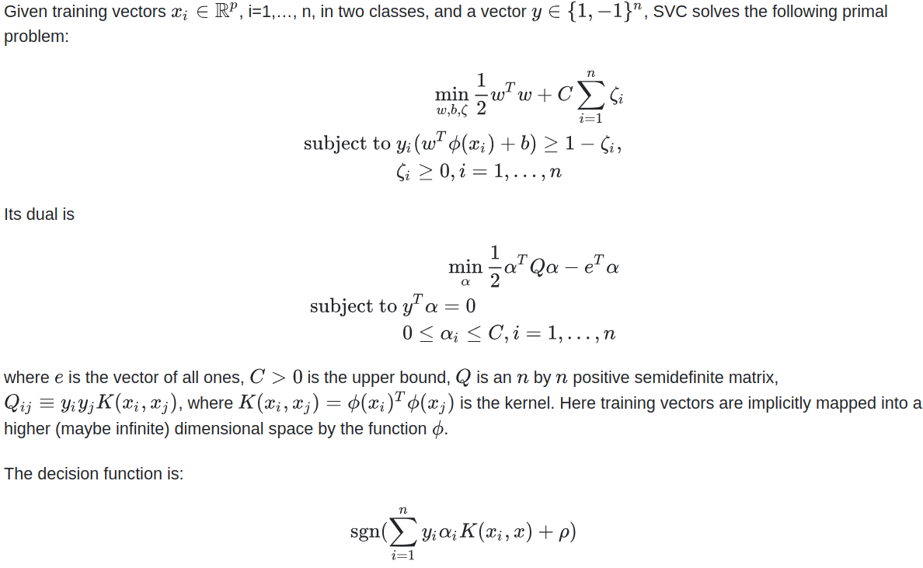
NuSVC:

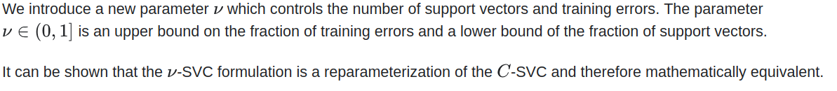
SVR:
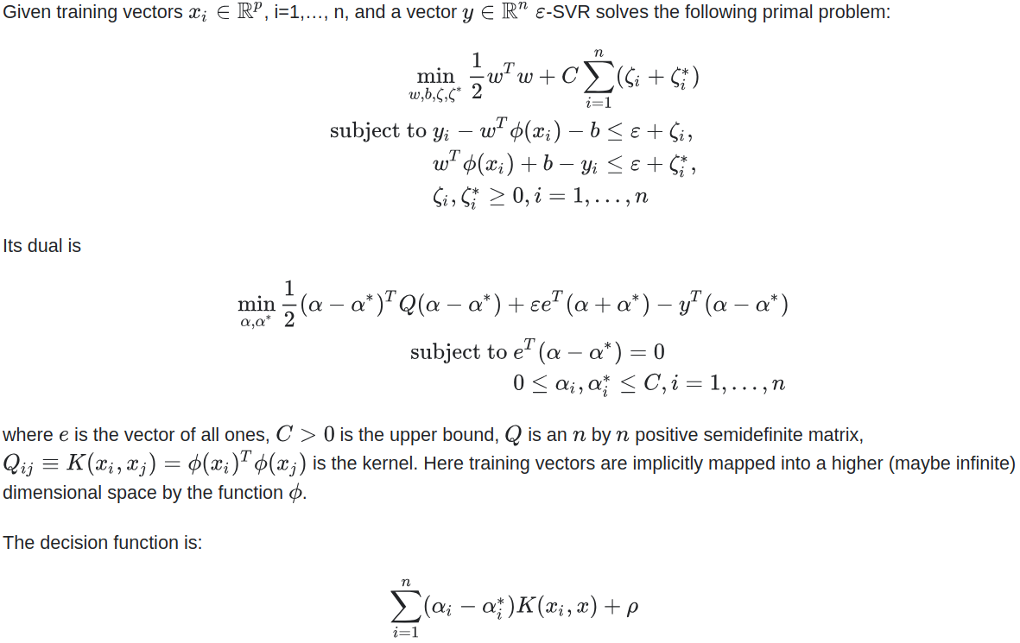

Here is a list of all kernel functions:
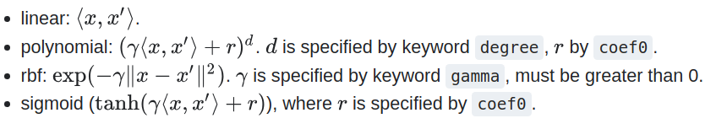

Part 3: Result and Analysis
Here are the result for kNN and SVM
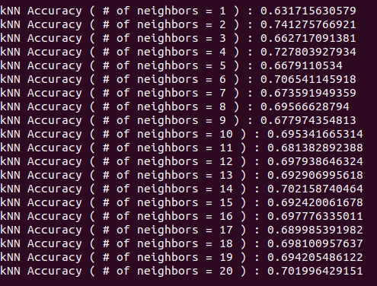 | 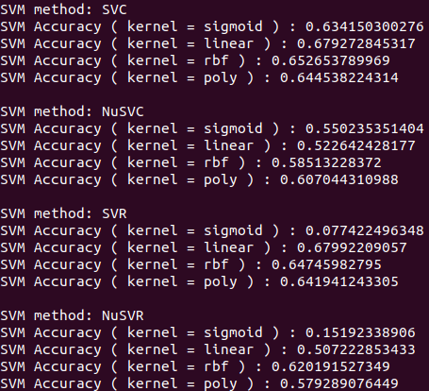

The best result for kNN comes from 2 neighbors and as more and more neighbors are added it converges to %70 accuracy. The best accuracy is %74. The less number of neighbors you use, the more susceptible it is to noisy data or misreading one. The more neighbors you choose the more robust it is.

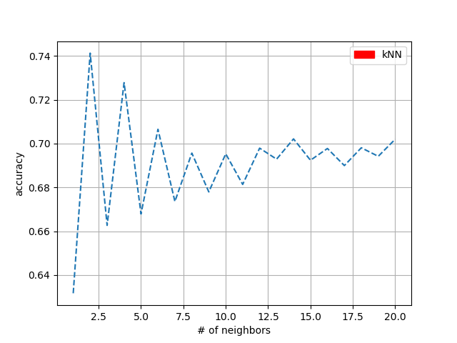

The best result for SVM comes from linear kernel of SVC and SVR. All nonlinear kernel such as rbf, polynomial, and sigmoid yield worse results. The justification for it is that the data is probably linear that nonlinear so a nonlinear kernel does not yield good.

The best result comes from linear SVC (%68) and linear SVR (%68).

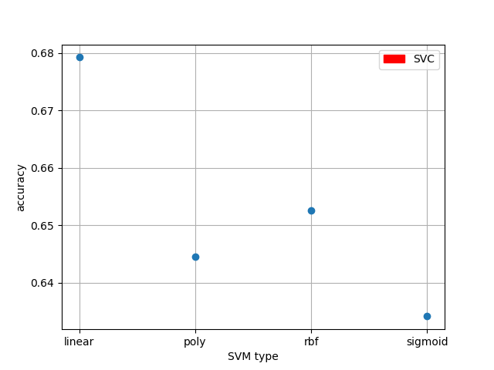 | 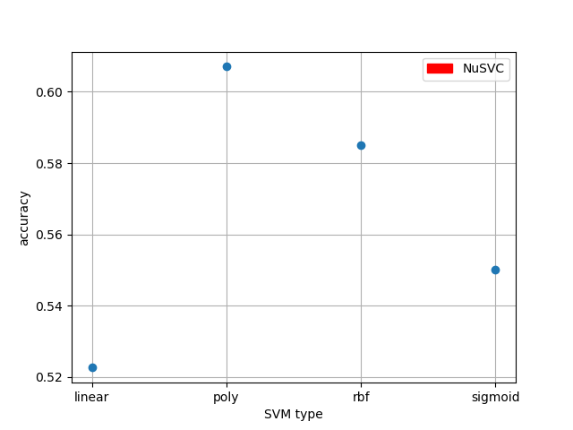
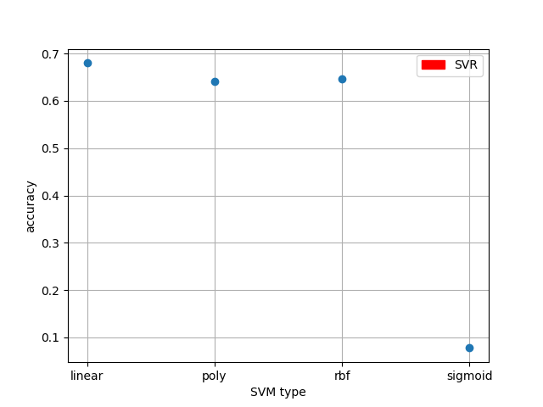 | 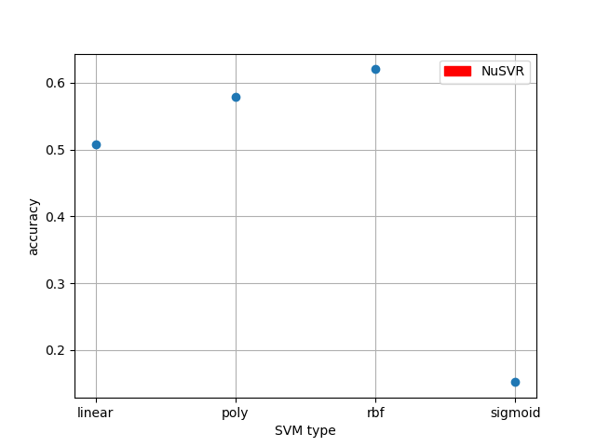

Part 4: Code

# This section of code is just dedicated to kNN and SVM. The previous pre-processing was already explained in lab 1

####################
'''
PART 4.0: arranging in an array and spliting test and train datasets

'''

print 'Arranging: '
print 'Before : ', data[0]

divide = float(2/3)
trainingMin = 0
trainingMax = int(int(len(data))*2/3)
testMin = trainingMax + 1
testMax = int(len(data))

#print trainingMin, trainingMax, testMin ,testMax

trainSet = []
trainClass = []
for i in range (trainingMin,trainingMax):
dataTemp = []
for j in range(0,len(data[0])):
if isinstance(data[i][j], list):
for w in range(0,len(data[i][j])):
#dataTemp.append(float(data[i][j][w])/2)
dataTemp.append(float(data[i][j][w]))
else:
dataTemp.append(float(data[i][j]))
trainSet.append(dataTemp)
trainClass.append(classList[i])

testSet = []
testClass = []
for i in range (testMin,testMax):
dataTemp = []
for j in range(0,len(data[0])):
if isinstance(data[i][j], list):
for w in range(0,len(data[i][j])):
#dataTemp.append(float(data[i][j][w])/2)
dataTemp.append(float(data[i][j][w]))
else:
dataTemp.append(data[i][j])
testSet.append(dataTemp)
testClass.append(classList[i])

print 'After : ', trainSet[0]
#raw_input()

####################
'''
PART 4.1: kNN

'''

print ''
#print 'kNN'

from sklearn.neighbors import NearestNeighbors

kNNx = []
kNNy = []
kNNMin = 1
kNNMax = 21
#kNNMax = 2
for NN in range(kNNMin,kNNMax):

neigh = NearestNeighbors(n_neighbors=NN)
neigh.fit(trainSet)

countTrue = 0
CountFalse = 0
for xx in range (testMin,testMax):

targetCell = xx - testMin
result = neigh.kneighbors([testSet[int(targetCell)]])

#print result
#raw_input()

sumTemp = 0.0
den = 0.0
for i in range(0,len(result[0][0])):

if float(result[0][0][i]) == 0.0:
w = 1000.0
else:
w = 1.0/float(result[0][0][i])

d = float(trainClass [result[1][0][i]])
sumTemp = w*d + sumTemp
den = w + den

#decision = float(sumTemp)/float(len(result[0][0]))
decision = float(sumTemp)/float(den)

if abs(int(testClass[targetCell])-decision)>0.5:
CountFalse = CountFalse + 1

else:
countTrue = countTrue + 1

accuracy = (float(countTrue)/float(countTrue+CountFalse))
print 'kNN Accuracy', '( # of neighbors =', NN, ') :' , accuracy

kNNx.append(NN)
kNNy.append(accuracy)

import matplotlib.pyplot as plt
import matplotlib.patches as mpatches

plt.figure(1)
#plt.subplot(211)
#grid(color='r', linestyle='-', linewidth=2)
plt.plot((kNNx), kNNy, '--')
plt.xlabel('# of neighbors')
plt.ylabel('accuracy')
red_patch = mpatches.Patch(color='red', label='kNN')
plt.legend(handles=[red_patch])
plt.grid(True)

####################
'''
PART 4.2: SVM

'''

#print 'SVM'
from sklearn import svm

SVMType = ['sigmoid','linear','rbf', 'poly']

SVMx = []
SVMy = []
print ''
print 'SVM method: SVC'
for SVMLoop in range (0,len(SVMType)):

#clf = svm.SVR(kernel=SVMType[SVMLoop])
clf = svm.SVC(kernel=SVMType[SVMLoop])
#clf = svm.NuSVC(kernel=SVMType[SVMLoop])
#clf = svm.NuSVR(kernel=SVMType[SVMLoop])
clf.fit(trainSet, trainClass)

countTrue = 0
CountFalse = 0
for xx in range (testMin,testMax):

targetCell = xx - testMin
result = clf.predict([testSet[targetCell]])

if abs(float(result[0])-float(testClass[targetCell]))>0.5:
CountFalse = CountFalse + 1

else:
countTrue = countTrue + 1

accuracy = (float(countTrue)/float(countTrue+CountFalse ))
print 'SVM Accuracy', '( kernel =',SVMType[SVMLoop],') :', accuracy
SVMx.append(SVMType[SVMLoop])
SVMy.append(accuracy)

plt.figure(2)
#plt.subplot(212)
plt.plot(SVMx, SVMy,'o')
plt.xlabel('SVM type')
plt.ylabel('accuracy')
red_patch = mpatches.Patch(color='red', label='SVC')
plt.legend(handles=[red_patch])
plt.grid(True)

SVMx = []
SVMy = []
print ''
print 'SVM method: NuSVC'
for SVMLoop in range (0,len(SVMType)):

#clf = svm.SVR(kernel=SVMType[SVMLoop])
#clf = svm.SVC(kernel=SVMType[SVMLoop])
clf = svm.NuSVC(kernel=SVMType[SVMLoop])
#clf = svm.NuSVR(kernel=SVMType[SVMLoop])
clf.fit(trainSet, trainClass)

countTrue = 0
CountFalse = 0
for xx in range (testMin,testMax):

targetCell = xx - testMin
result = clf.predict([testSet[targetCell]])

if abs(float(result[0])-float(testClass[targetCell]))>0.5:
CountFalse = CountFalse + 1

else:
countTrue = countTrue + 1

accuracy = (float(countTrue)/float(countTrue+CountFalse ))
print 'SVM Accuracy', '( kernel =',SVMType[SVMLoop],') :', accuracy
SVMx.append(SVMType[SVMLoop])
SVMy.append(accuracy)

plt.figure(3)
plt.plot(SVMx, SVMy,'o')
plt.xlabel('SVM type')
plt.ylabel('accuracy')
red_patch = mpatches.Patch(color='red', label='NuSVC')
plt.legend(handles=[red_patch])
plt.grid(True)

SVMx = []
SVMy = []
print ''
print 'SVM method: SVR'
for SVMLoop in range (0,len(SVMType)):

clf = svm.SVR(kernel=SVMType[SVMLoop])
#clf = svm.SVC(kernel=SVMType[SVMLoop])
#clf = svm.NuSVC(kernel=SVMType[SVMLoop])
#clf = svm.NuSVR(kernel=SVMType[SVMLoop])
clf.fit(trainSet, trainClass)

countTrue = 0
CountFalse = 0
for xx in range (testMin,testMax):

targetCell = xx - testMin
result = clf.predict([testSet[targetCell]])

if abs(float(result[0])-float(testClass[targetCell]))>0.5:
CountFalse = CountFalse + 1

else:
countTrue = countTrue + 1

accuracy = (float(countTrue)/float(countTrue+CountFalse ))
print 'SVM Accuracy', '( kernel =',SVMType[SVMLoop],') :', accuracy
SVMx.append(SVMType[SVMLoop])
SVMy.append(accuracy)

plt.figure(4)
plt.plot(SVMx, SVMy,'o')
plt.xlabel('SVM type')
plt.ylabel('accuracy')
red_patch = mpatches.Patch(color='red', label='SVR')
plt.legend(handles=[red_patch])
plt.grid(True)

SVMx = []
SVMy = []
print ''
print 'SVM method: NuSVR'
for SVMLoop in range (0,len(SVMType)):

#clf = svm.SVR(kernel=SVMType[SVMLoop])
#clf = svm.SVC(kernel=SVMType[SVMLoop])
#clf = svm.NuSVC(kernel=SVMType[SVMLoop])
clf = svm.NuSVR(kernel=SVMType[SVMLoop])
clf.fit(trainSet, trainClass)

countTrue = 0
CountFalse = 0
for xx in range (testMin,testMax):

targetCell = xx - testMin
result = clf.predict([testSet[targetCell]])

if abs(float(result[0])-float(testClass[targetCell]))>0.5:
CountFalse = CountFalse + 1

else:
countTrue = countTrue + 1

accuracy = (float(countTrue)/float(countTrue+CountFalse ))
print 'SVM Accuracy', '( kernel =',SVMType[SVMLoop],') :', accuracy
SVMx.append(SVMType[SVMLoop])
SVMy.append(accuracy)

plt.figure(5)
plt.plot(SVMx, SVMy,'o')
plt.xlabel('SVM type')
plt.ylabel('accuracy')
red_patch = mpatches.Patch(color='red', label='NuSVR')
plt.legend(handles=[red_patch])
plt.grid(True)

plt.show()

